### 18ECP101L-MASSIVE OPEN ONLINE COURSE-I

### SEMESTER V

**YEAR: NOV 2022**

### *Introduction to Systems Engineering*

***Report Submitted by***

**Kunal Keshan [RA2011004010051]**

***Faculty in-charge***

## Mrs.S.Murugaveni



## DEPARTMENT OF ELECTRONICS AND COMMUNICATION ENGINEERING

### FACULTY OF ENGINEERING AND TECHNOLOGY

**SRM INSTITUTE OF SCIENCE AND TECHNOLOGY**

S.R.M. Nagar, Kattankulathur - 603203, Kancheepuram District

**TABLE OF CONTENTS**

| **S.NO** | **TITLE** | **PAGE NO.** |
| --- | --- | --- |
| 1. | COURSE DETAILS | 3 |
| 2. | INSTRUCTOR PROFILE | 4 |
| 3. | INTRODUCTION OF THE COURSE | 5 |
| 4. | COURSE TIMELINE | 6 |
| 5. | SYLLABUS | 7 |
| 6. | WEEK-1 CONTENTS |  |
| 7. | WEEK-2 CONTENTS |  |
| 8. | WEEK-3 CONTENTS |  |
| 9. | WEEK-4 CONTENTS |  |
| 10. | WEEK-5 CONTENTS |  |
| 11. | WEEK-6 CONTENTS |  |
| 12. | WEEK-7 CONTENTS |  |
| 13. | WEEK-8 CONTENTS |  |
| 14. | WEEK-9 CONTENTS |  |
| 15. | COURSE GRADE DETAILS (INCLUDING QUIZ/ ASSIGNMENT GRADES) |  |
| 16. | COURSE OUTCOME |  |
| 17. | PROOF OF COURSE COMPLETION |  |

1. **COURSE DETAILS**

**COURSE PLATFORM- Coursera**

**COURSE TITLE- Introduction to Systems Engineering**

**OFFERING UNIVERSITY- The University of New South Wales, Sydney**

**COURSE DURATION- 22 hours**

**DASHBOARD:**

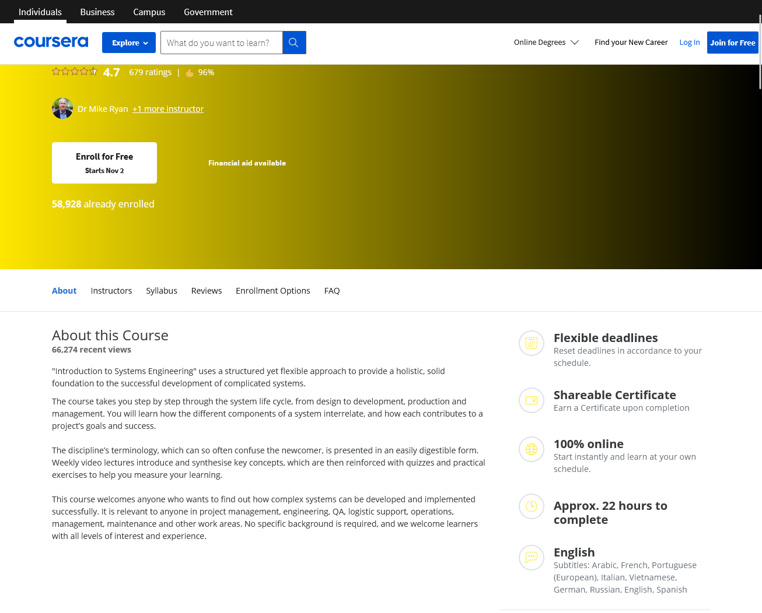

1. **INSTRUCTOR PROFILE**

** Dr Mike Ryan (Senior Lecturer) at UNSW Sydney**

Dr Mike Ryan holds bachelors, masters, and PhD degrees in electrical engineering. He is a Fellow of Engineers Australia (FIEAust), a Chartered Professional Engineer (CPEng) in the electrical and ITEE colleges, a Senior Member of IEEE (SMIEEE), a Member of the Australian Institute of Management (AIMM), and a member of the International Council on Systems Engineering (INCOSE). Since 1981, he has held a number of positions in communications and systems engineering and in management and project management.

Since 1998, he has been with the School of Engineering and Information Technology, UNSW, in Canberra where he is currently a Senior Lecturer. His research and teaching interests are in communications and information systems, requirements engineering, systems engineering, and project management—he also regularly consults in those fields.

He is the Editor-in-Chief of an international journal, the Conference Chair of two major international conferences each year, and is the Chair of the Requirements Working Group (RWG) of INCOSE. He is the author or co-author of twelve books, three book chapters, and over 180 technical papers and reports.

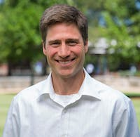 **Dr Ian Faulconbridge (Inductry Fellow) at UNSW Sydney**

Dr Ian Faulconbridge has doctorate, masters, and bachelors degrees in engineering and an MBA in project management. He is a Fellow of Engineers Australia (FIEAust), a Chartered Professional Engineer (CPEng) in the electrical and aerospace colleges, and is a Registered Professional Engineer of Queensland (RPEQ). He is also a Senior Member of IEEE (SMIEEE) and a member of the International Council on Systems Engineering (INCOSE).

Since 1990, he has held a number of engineering, project management and academic positions in the fields of avionics, simulation, radar, communications and information systems. He is the director of an engineering and project management consultancy and is an Industry Fellow with the School of Engineering and Information Technology, UNSW, in Canberra.

He is the author or co-author of a number of books covering project management, systems engineering, radar and avionics, and is the co-author of a book chapter covering the design of engineering educational programs. Additionally, he has written a number of academic papers, technical reports and professional papers covering a range of technical and management topics.

1. **INTRODUCTION OF THE COURSE**

"Introduction to Systems Engineering" uses a structured yet flexible approach to provide a holistic, solid foundation to the successful development of complicated systems.

The course takes you step by step through the system life cycle, from design to development, production and management. You will learn how the different components of a system interrelate, and how each contributes to a project’s goals and success.

The discipline’s terminology, which can so often confuse the newcomer, is presented in an easily digestible form. Weekly video lectures introduce and synthesise key concepts, which are then reinforced with quizzes and practical exercises to help you measure your learning.

This course welcomes anyone who wants to find out how complex systems can be developed and implemented successfully. It is relevant to anyone in project management, engineering, QA, logistic support, operations, management, maintenance and other work areas. No specific background is required, and we welcome learners with all levels of interest and experience.

1. **COURSE TIMELINE**

DATE OF ENROLLMENT: 22nd August 2022

DATE OF COMPLETION: 8th November 2022

1. **SYLLABUS**

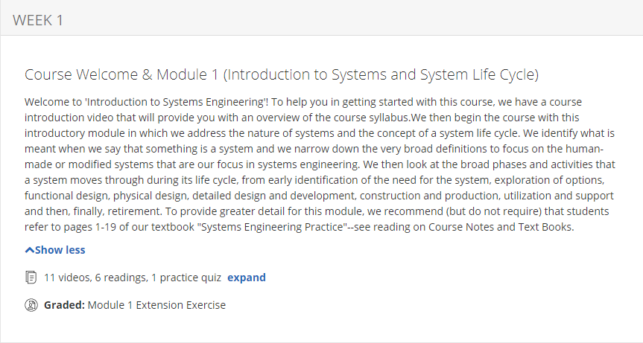

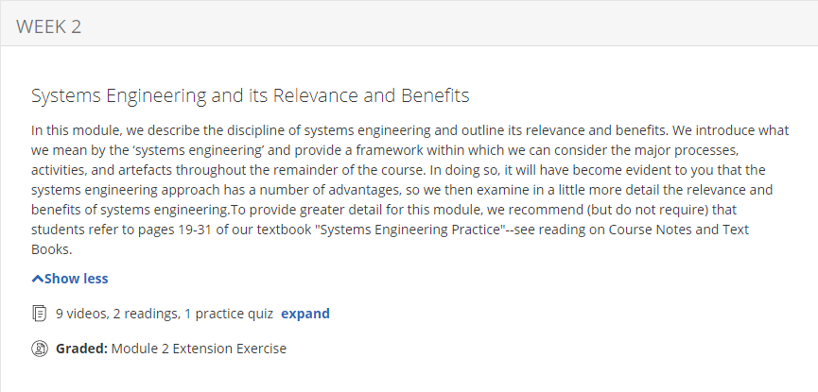

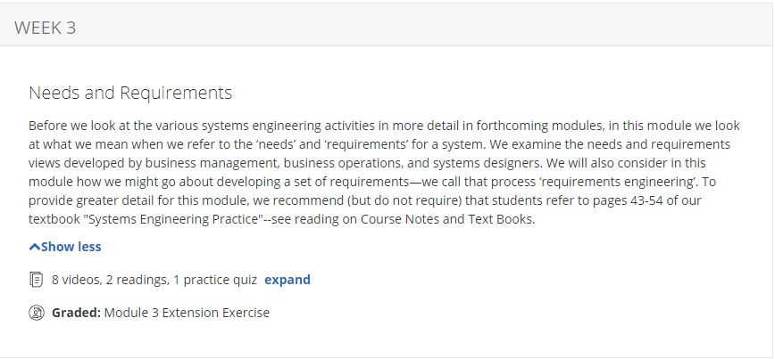

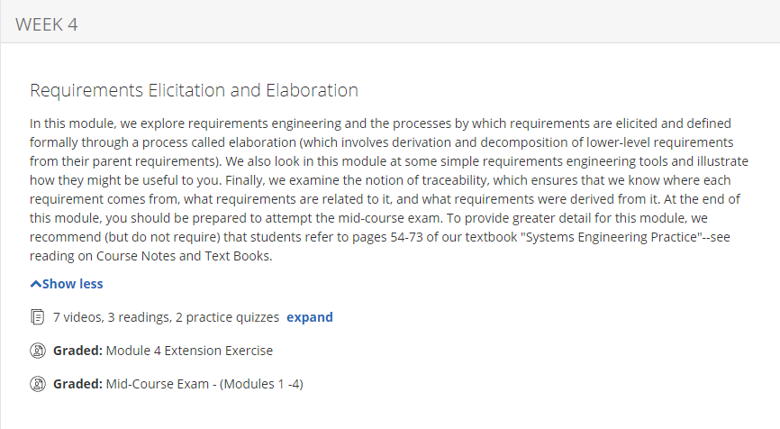

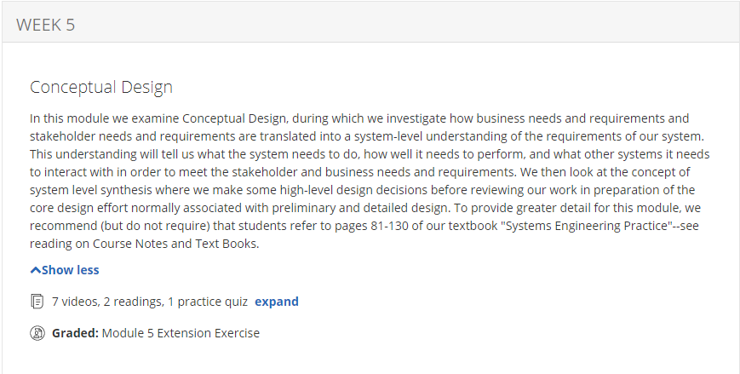

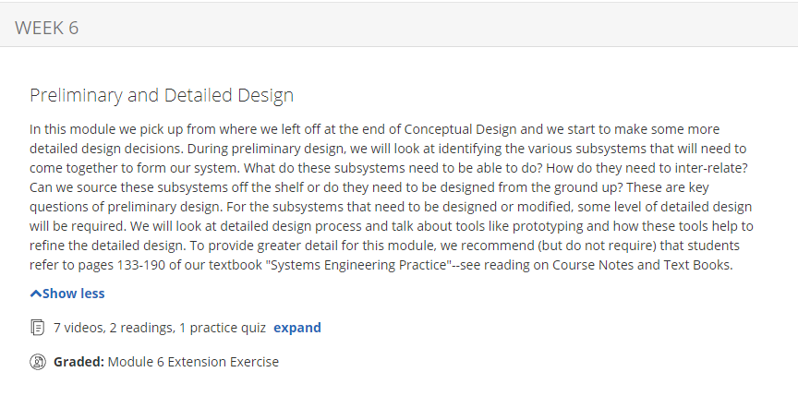

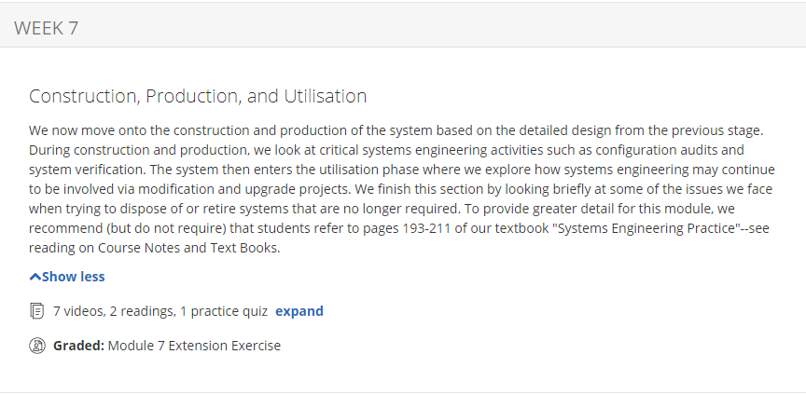

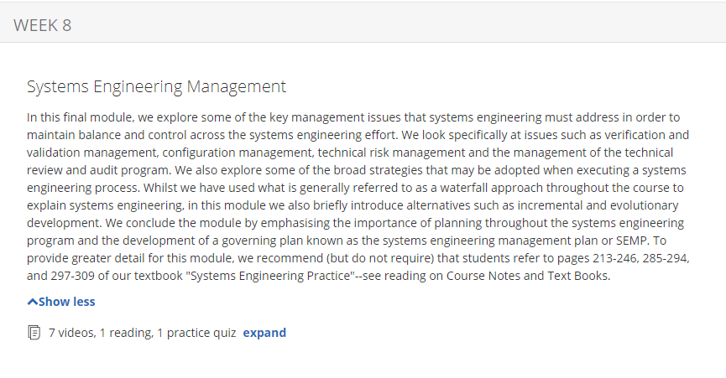

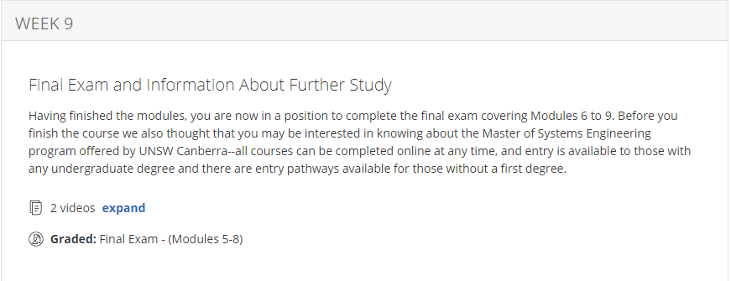

**WEEKLY REFERENCE MATERIAL**

**MODULE 1:**

[**https://forescout-wpengine.netdna-ssl.com/wp-content/uploads/2018/07/2018-SANS-Industrial-IoT-Security-Survey.pdf**](https://forescout-wpengine.netdna-ssl.com/wp-content/uploads/2018/07/2018-SANS-Industrial-IoT-Security-Survey.pdf)

**MODULE 2:**

[**https://www.nytimes.com/2018/10/10/technology/future-internet-of-things.html**](https://www.nytimes.com/2018/10/10/technology/future-internet-of-things.html)

**MODULE 3:**

[**https://www.computer.org/web/sensing-iot/content?g=53926943&type=article&urlTitle=what-are-the-components-of-iot-**](https://www.computer.org/web/sensing-iot/content?g=53926943&type=article&urlTitle=what-are-the-components-of-iot-)

**MODULE 4:**

[**http://www.computerworld.com/article/2886316/mobile-networks-prep-for-the-internet-of-things.html**](http://www.computerworld.com/article/2886316/mobile-networks-prep-for-the-internet-of-things.html)

[**http://www.csoonline.com/article/2947477/network-security/security-and-the-internet-of-things-are-we-repeating-history.html**](http://www.csoonline.com/article/2947477/network-security/security-and-the-internet-of-things-are-we-repeating-history.html)

1. **WEEK 1 CONTENTS**

* **Reference material**
* **Consolidated write-up of the week-1topics**

(Write about the topic discussed in week-1 based on your understanding-minimum two pages)

* **Assignment/Quiz Details**

**Q)** Identify and analyse a device that is an IoT device now, but in the past was a non-IoT device. Describe and list the features of the device. Compare the functions of the device in the past to the functions of the device now.

**ANS:**A smart phone is an IoT device now but wasn't so earlier.

FEATURES OF THE DEVICE:

* Internet connectivity
* mobile browser
* embedded memory
* wireless synchronisation with other devices
* ability to download applications to run them independently
* support for third-party applications
* Wi-Fi
* digital camera
* gaming
* GPS etc

**Q)** Compare the functions of the device in the past to the functions of the device now.

**ANS :** COMPARISON:

* Both smart phones and cell phones can make calls.
* Both smart phones and cell phones can send texts.
* smart phones allow the user to surf the internet unlike cell phones.
* smart phones can help download several apps but cell phones do not offer that feature.
* cell phones have physical keyboard whereas smart phones have virtual keyboard.
* the camera quality of cell phone is average whereas it is of high quality in smart phones.

**Q)** For your chosen IoT device, list any improvements or any diminishments if they exist, over the non-IOT device. Describe any limitations that are present in the new IoT version of the device.

**ANS :** IMPROVEMENTS:

* Smart phones have better hardware than cell phones. They have high resolution screens, keyboard, cameras, sensors, processors, software.
* smart phones have supported applications, network infrastructures i.e 3G and 4G networks, increasing wireless bandwidth, cloud storage ability which cell phones do not have.
* using the smart phones accelerometer, health indicators can be followed.
* Using the GPS, traffic patterns could be monitored.
* with internet connectivity allowed and high quality sensors, a smart phone can be used topoint at a restaurant and see customer reviews about it.

LIMITATIONS:

* they are costly
* people spend a lot of time on phones ,so there is less social interaction.
* health issues due to overuse of phones
* privacy threats
* uncensored content
* smart phones don't age well
* most of the apps require internet access
* data privacy and security is a significant concern

**Q)** Describe any privacy issues with the IoT device that never existed in the original version of the device. Compare the price of the original device to the price of the new IoT version of the device. When performing a price comparison, attempt to normalize for the changing value of currency over time by using an online inflation calculator.

**ANS :** Healthcare organizations have long been concerned about data privacy and security. This was the case before information could travel so freely outside their facility walls as it can now thanks to smartphones and other devices, such as laptops, tablets, and portable hard drives. If a smartphone is lost or stolen and lacks proper levels of security, the information stored on it and accessible via apps can be viewed and possibly downloaded. Such a scenario could have significant legal and financial implications for an organization and clinician.

A major barrier to smartphone adoption is cost, with newer smartphones typically running at least several hundred dollars, and some models exceeding $1,000. These high costs are also contributing to owners holding onto their devices for longer.

1. **WEEK 2 CONTENTS**

* **Reference material**
* **Consolidated write-up of the week-2 topics**

(Write about the topic discussed in week-2 based on your understanding-minimum two pages)

* **Assignment/Quiz Details**

1. **WEEK 3 CONTENTS**

* **Reference material**
* **Consolidated write-up of the week-3 topics**

(Write about the topic discussed in week-3 based on your understanding-minimum two pages)

* **Assignment/Quiz Details**

1. **WEEK 4 CONTENTS**

* **Reference material**
* **Consolidated write-up of the week-4 topics**

(Write about the topic discussed in week-4 based on your understanding-minimum two pages)

* **Assignment/Quiz Details**

1. **COURSE GRADE DETAILS**

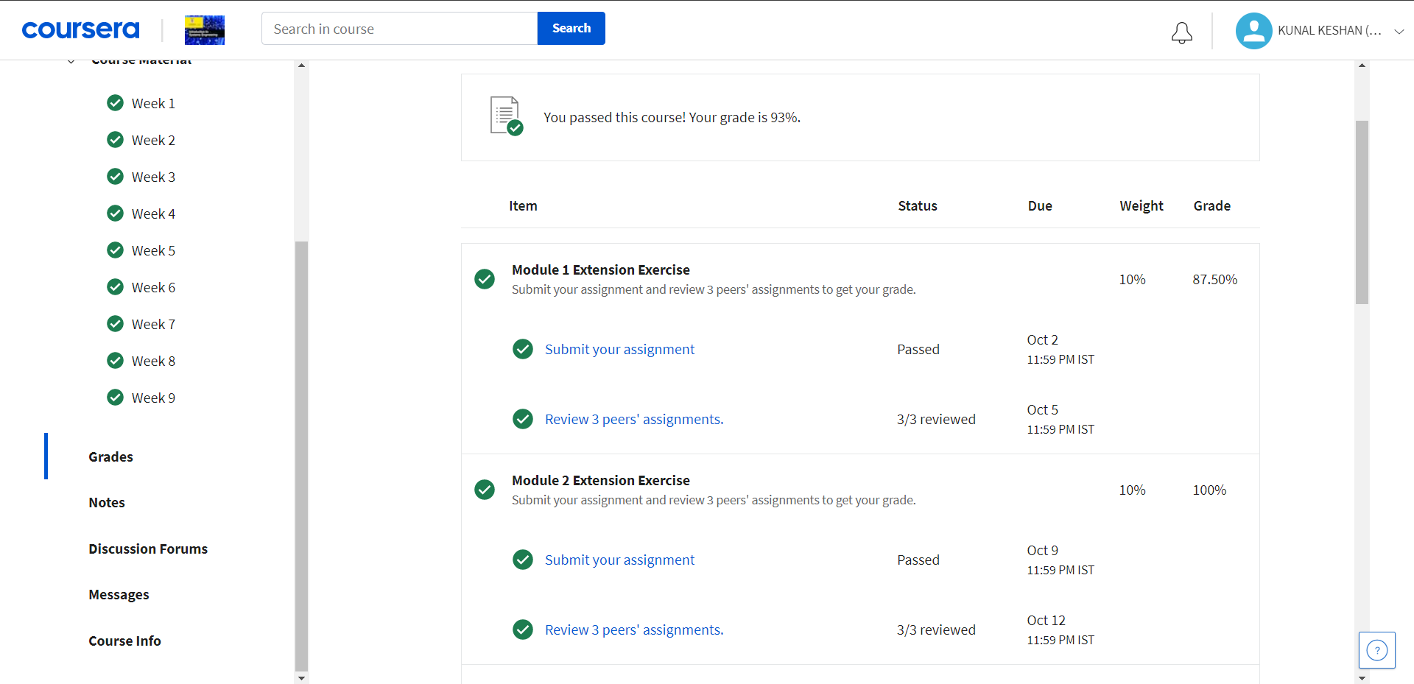

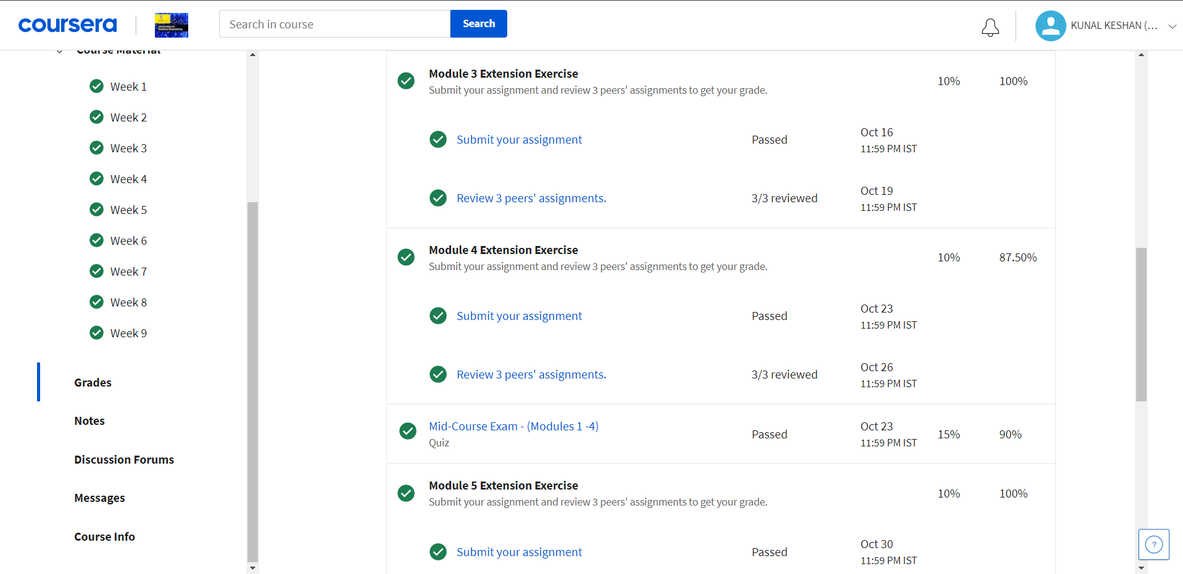

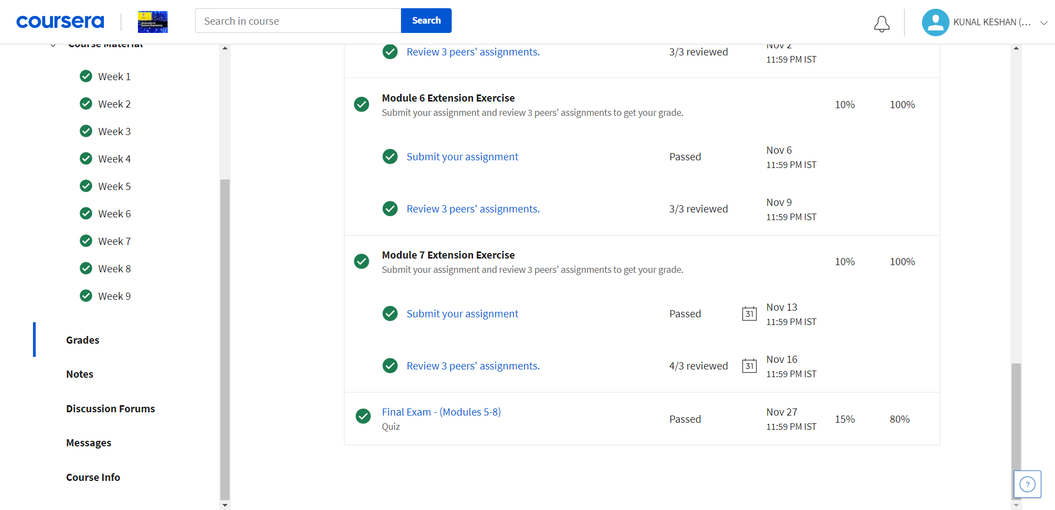

1. **COURSE OUTCOMES**

**(Write about future scope and application of the course)**

1. **PROOF OF COURSE COMPLETION**

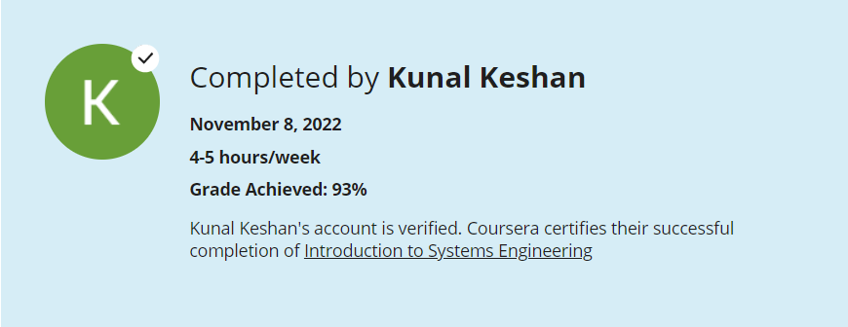

**COURSE CERTIFICATE**

